#include<stdio.h>

#include<conio.h>

#include<graphics.h>

#include<dos.h>

astable();

astable_val();

astable_close();

astable();

ledani(int);

int main()

{

int v=0,r=0;

float c=0,r1=0,t=1;

char a[50];

int gd=DETECT,gm;

initgraph(&gd,&gm,"C:\\TURBOC3\\BGI");

printf("Enter circuit DC voltage\n");

scanf("%d",&v);

printf("\nEnter value of capacitance in uF\n");

scanf("%f",&c);

printf("\nEnter value of LED resistances in ohm\n");

scanf("%d",&r);

printf("\nEnter value of circuit resistances in K-ohm\n");

scanf("%f",&r1);

t=c*r1;

printf("\nRC Time Constant=%0.1fms",t);

getch();

cleardevice();

astable();

sprintf(a,"%d",r);

outtextxy(80,120,a);

outtextxy(120,120,a);

outtextxy(160,120,a);

outtextxy(200,120,a);

outtextxy(240,120,a);

outtextxy(405,120,a);

outtextxy(445,120,a);

outtextxy(485,120,a);

outtextxy(525,120,a);

outtextxy(565,120,a);

sprintf(a,"%0.1f uF",c);

outtextxy(80,315,a);

outtextxy(395,315,a);

sprintf(a,"%0.1f",r1);

outtextxy(390,390,a);

outtextxy(440,390,a);

outtextxy(390,400,"K-ohm");

outtextxy(445,400,"K-ohm");

outtextxy(80,130,"ohm ohm ohm ohm ohm");

outtextxy(405,130,"ohm ohm ohm ohm ohm");

setcolor(RED);

sprintf(a,"%dV",v);

outtextxy(610,270,a);

outtextxy(610,280,"DC");

setcolor(BLUE);

line(535,450,555,450);

ledani(t);

getch();

return 0;

}

ledani(int x)

{

int a= 50, b=76,c=4;

while(!kbhit())

{

setfillstyle(SOLID_FILL,c);

floodfill(a,b,BLACK);

delay(x*100);

setfillstyle(SOLID_FILL,15);

floodfill(a,b,BLACK);

a+=40;

if(a>210&&a<380)

{

a=380;

c=2;

}

if(a>540)

{

a=50;

c=4;

}

}

return 0;

}

astable_close()

{

astable();

getch();

return 0;

}

astable()

{

floodfill(10,10,WHITE);

setcolor(BLACK);

line(50,100,210,100);

line(50,101,210,101);

line(375,100,535,100);

line(375,101,535,101);

line(50,100,50,290);

line(51,100,51,290);

line(50,340,50,370);

line(51,340,51,370);

line(50,370,490,370);

line(50,369,490,369);

line(490,240,490,380);

line(491,240,491,380);

line(375,100,375,290);

line(376,100,376,290);

rectangle(370,381,380,400); //RESISTOR1

rectangle(485,381,495,400); //RESISTOR2

setfillstyle(SOLID_FILL,BROWN);

floodfill(375,390,BLACK);

floodfill(490,390,BLACK);

rectangle(170,190,190,220); //NPN Transistor for RED LEDs

line(170,250,170,240); //wire connected to NPN collector (RED LED)

line(169,250,169,240);

line(50,250,170,250);

line(50,249,170,249);

line(191,240,191,460); //wire connected to NPN emitter (RED LED)

line(192,240,192,460);

line(169,240,175,220); //collector

line(180,220,180,240); //base

line(185,220,191,240); //emitter

line(191,450,520,450);

line(191,449,520,449);

line(570,450,590,450);

line(570,449,590,449);

line(590,450,590,285);

line(589,450,589,285);

line(180,461,205,461); //ground

line(184,465,201,465);

line(188,469,197,469);

rectangle(480,190,500,220); //NPN Transistor for GREEN LEDs

setfillstyle(SOLID_FILL,7);

floodfill(490,200,BLACK);

floodfill(180,200,BLACK);

line(480,250,480,240); //wire connected to NPN collector (GREEN LED)

line(479,250,479,240);

line(375,250,480,250);

line(375,249,480,249);

line(501,240,501,450); //wire connected to NPN emitter (GREEN LED)

line(502,240,502,450);

line(479,240,485,220); //collector

line(490,220,490,240); //base

line(495,220,501,240); //emitter

line(45,79,75,79); //RED LED #1

line(45,79,45,75);

line(75,79,75,75);

line(45,75,50,75);

line(70,75,75,75);

line(50,75,50,65);

line(70,75,70,65);

arc(60,65,0,180,10);

line(85,79,115,79); //RED LED #2

line(85,79,85,75);

line(115,79,115,75);

line(85,75,90,75);

line(110,75,115,75);

line(90,75,90,65);

line(110,75,110,65);

arc(100,65,0,180,10);

line(125,79,155,79); //RED LED #3

line(125,79,125,75);

line(155,79,155,75);

line(125,75,130,75);

line(150,75,155,75);

line(130,75,130,65);

line(150,75,150,65);

arc(140,65,0,180,10);

line(165,79,195,79); //RED LED #4

line(165,79,165,75);

line(195,79,195,75);

line(165,75,170,75);

line(190,75,195,75);

line(170,75,170,65);

line(190,75,190,65);

arc(180,65,0,180,10);

line(205,79,235,79); //RED LED #5

line(205,79,205,75);

line(235,79,235,75);

line(205,75,210,75);

line(230,75,235,75);

line(210,75,210,65);

line(230,75,230,65);

arc(220,65,0,180,10);

line(370,79,400,79); //GREEN LED #1

line(370,79,370,75);

line(400,79,400,75);

line(370,75,375,75);

line(395,75,400,75);

line(375,75,375,65);

line(395,75,395,65);

arc(385,65,0,180,10);

line(410,79,440,79); //GREEN LED #2

line(410,79,410,75);

line(440,79,440,75);

line(410,75,415,75);

line(435,75,440,75);

line(415,75,415,65);

line(435,75,435,65);

arc(425,65,0,180,10);

line(450,79,480,79); //GREEN LED #3

line(450,79,450,75);

line(480,79,480,75);

line(450,75,455,75);

line(475,75,480,75);

line(455,75,455,65);

line(475,75,475,65);

arc(465,65,0,180,10);

line(490,79,520,79); //GREEN LED #4

line(490,79,490,75);

line(520,79,520,75);

line(490,75,495,75);

line(515,75,520,75);

line(495,75,495,65);

line(515,75,515,65);

arc(505,65,0,180,10);

line(530,79,560,79); //GREEN LED #5

line(530,79,530,75);

line(560,79,560,75);

line(530,75,535,75);

line(555,75,560,75);

line(535,75,535,65);

line(555,75,555,65);

arc(545,65,0,180,10);

setcolor(BROWN);

line(51,100,51,80); //RED LED #1 wires

line(50,100,50,80);

line(71,80,71,90);

line(70,80,70,90);

line(91,100,91,80); //RED LED #2 wires

line(90,100,90,80);

line(111,80,111,90);

line(110,80,110,90);

line(131,100,131,80); //RED LED #3 wires

line(130,100,130,80);

line(151,80,151,90);

line(150,80,150,90);

line(171,100,171,80); //RED LED #4 wires

line(170,100,170,80);

line(191,80,191,90);

line(190,80,190,90);

line(211,100,211,80); //RED LED #5 wires

line(210,100,210,80);

line(231,80,231,90);

line(230,80,230,90);

line(376,100,376,80); //GREEN LED #1 wires

line(375,100,375,80);

line(396,80,396,90);

line(395,80,395,90);

line(416,100,416,80); //GREEN LED #2 wires

line(415,100,415,80);

line(436,80,436,90);

line(435,80,435,90);

line(456,100,456,80); //GREEN LED #3 wires

line(455,100,455,80);

line(476,80,476,90);

line(475,80,475,90);

line(496,100,496,80); //GREEN LED #4 wires

line(495,100,495,80);

line(516,80,516,90);

line(515,80,515,90);

line(536,100,536,80); //GREEN LED #5 wires

line(535,100,535,80);

line(556,80,556,90);

line(555,80,555,90);

setcolor(RED);

line(72,90,72,110); //RED LED #1 connector

line(73,90,73,110);

line(112,90,112,110); //RED LED #2 connector

line(113,90,113,110);

line(152,90,152,110); //RED LED #3 connector

line(153,90,153,110);

line(192,90,192,110); //RED LED #4 connector

line(193,90,193,110);

line(232,90,232,110); //RED LED #5 connector

line(233,90,233,110);

line(397,90,397,110); //GREEN LED #1 connector

line(398,90,398,110);

line(437,90,437,110); //GREEN LED #2 connector

line(438,90,438,110);

line(477,90,477,110); //GREEN LED #3 connector

line(478,90,478,110);

line(517,90,517,110); //GREEN LED #4 connector

line(518,90,518,110);

line(557,90,557,110); //GREEN LED #5 connector

line(558,90,558,110);

line(180,240,180,360); //wire connected to NPN base (RED LED)

line(181,240,181,360);

line(180,360,375,360);

line(180,359,375,359);

line(375,345,375,380);

line(376,345,376,380);

line(375,401,375,420);

line(376,401,376,420);

line(350,420,490,420);

line(350,419,490,419);

line(490,420,490,401);

line(489,420,489,401);

line(73,140,73,170); //RED LEDs connected to main wire

line(74,140,74,170);

line(113,140,113,170);

line(114,140,114,170);

line(153,140,153,420);

line(154,140,154,420); //**

line(153,420,270,420);

line(153,419,270,419);

line(193,140,193,170);

line(194,140,194,170);

line(233,140,233,170);

line(234,140,234,170);

line(73,169,590,169);

line(73,170,590,170);

line(590,170,590,270);

line(589,170,589,270);

line(580,270,600,270);

line(585,275,595,275);

line(580,280,600,280);

line(585,285,595,285);

line(398,140,398,170); //GREEN LEDs connected to main wire

line(399,140,399,170);

line(438,140,438,170);

line(439,140,439,170);

line(478,140,478,170);

line(479,140,479,170);

line(518,140,518,170);

line(519,140,519,170);

line(558,140,558,170);

line(559,140,559,170);

setcolor(BLUE);

line(73,110,73,115); //R1

line(73,115,76,118);

line(76,118,73,121);

line(73,121,76,124);

line(76,124,73,127);

line(73,127,76,130);

line(76,130,73,133);

line(73,133,73,140);

line(113,110,113,115); //R2

line(113,115,116,118);

line(116,118,113,121);

line(113,121,116,124);

line(116,124,113,127);

line(113,127,116,130);

line(116,130,113,133);

line(113,133,113,140);

line(153,110,153,115); //R3

line(153,115,156,118);

line(156,118,153,121);

line(153,121,156,124);

line(156,124,153,127);

line(153,127,156,130);

line(156,130,153,133);

line(153,133,153,140);

line(193,110,193,115); //R4

line(193,115,196,118);

line(196,118,193,121);

line(193,121,196,124);

line(196,124,193,127);

line(193,127,196,130);

line(196,130,193,133);

line(193,133,193,140);

line(233,110,233,115); //R5

line(233,115,236,118);

line(236,118,233,121);

line(233,121,236,124);

line(236,124,233,127);

line(233,127,236,130);

line(236,130,233,133);

line(233,133,233,140);

line(398,110,398,115); //R1

line(398,115,401,118);

line(401,118,398,121);

line(398,121,401,124);

line(401,124,398,127);

line(398,127,401,130);

line(401,130,398,133);

line(398,133,398,140);

line(438,110,438,115); //R2

line(438,115,441,118);

line(441,118,438,121);

line(438,121,441,124);

line(441,124,438,127);

line(438,127,441,130);

line(441,130,438,133);

line(438,133,438,140);

line(478,110,478,115); //R3

line(478,115,481,118);

line(481,118,478,121);

line(478,121,481,124);

line(481,124,478,127);

line(478,127,481,130);

line(481,130,478,133);

line(478,133,478,140);

line(518,110,518,115); //R4

line(518,115,521,118);

line(521,118,518,121);

line(518,121,521,124);

line(521,124,518,127);

line(518,127,521,130);

line(521,130,518,133);

line(518,133,518,140);

line(558,110,558,115); //R5

line(558,115,561,118);

line(561,118,558,121);

line(558,121,561,124);

line(561,124,558,127);

line(558,127,561,130);

line(561,130,558,133);

line(558,133,558,140);

line(50,290,50,320);

line(50,326,50,345);

line(40,320,60,320); //C1

line(40,321,60,321);

line(40,325,60,325);

line(40,326,60,326);

line(375,290,375,320);

line(375,326,375,345);

line(365,320,385,320); //C2

line(365,321,385,321);

line(365,325,385,325);

line(365,326,385,326);

line(270,420,280,420); //rheostat

line(280,420,285,415);

line(285,415,290,425);

line(290,425,300,415);

line(300,415,305,425);

line(305,425,315,415);

line(315,415,320,425);

line(320,425,325,420);

line(325,420,340,420);

line(340,420,350,420);

line(320,400,280,430);

line(280,430,290,428);

line(280,430,282,425);

line(520,450,530,450); //switch

circle(532,450,2);

line(560,450,570,450);

circle(558,450,2);

setcolor(YELLOW);

line(371,385,379,385);

line(371,386,379,386);

line(486,385,494,385);

line(486,386,494,386);

setcolor(9);

line(371,388,379,388);

line(371,389,379,389);

line(486,388,494,388);

line(486,389,494,389);

setcolor(10);

line(371,391,379,391);

line(371,392,379,392);

line(486,391,494,391);

line(486,392,494,392);

setcolor(13);

line(371,393,379,393);

line(371,394,379,394);

line(486,393,494,393);

line(486,394,494,394);

setcolor(BLUE);

outtextxy(70,235,"COLLECTOR");

outtextxy(400,235,"COLLECTOR");

outtextxy(200,190,"NPN");

outtextxy(200,200,"2N3904");

outtextxy(510,190,"NPN");

outtextxy(510,200,"2N3904");

outtextxy(230,435,"0-10 K-ohm Variable Resistor");

outtextxy(280,400,"10%");

outtextxy(170,260,"B");

outtextxy(170,270,"A");

outtextxy(170,280,"S");

outtextxy(170,290,"E");

outtextxy(200,240,"E");

outtextxy(200,250,"M");

outtextxy(200,260,"I");

outtextxy(200,270,"T");

outtextxy(200,280,"T");

outtextxy(200,290,"E");

outtextxy(200,300,"R");

outtextxy(480,260,"B");

outtextxy(480,270,"A");

outtextxy(480,280,"S");

outtextxy(480,290,"E");

outtextxy(510,240,"E");

outtextxy(510,250,"M");

outtextxy(510,260,"I");

outtextxy(510,270,"T");

outtextxy(510,280,"T");

outtextxy(510,290,"E");

outtextxy(510,300,"R");

outtextxy(380,310,"+");

outtextxy(390,330,"CAPACITOR");

outtextxy(55,310,"+");

outtextxy(70,330,"CAPACITOR");

outtextxy(520,460,"SWITCH");

outtextxy(80,90,"+ + + + +");

outtextxy(405,90,"+ + + + +");

getch();

return 0;

}

**OUTPUTS:**

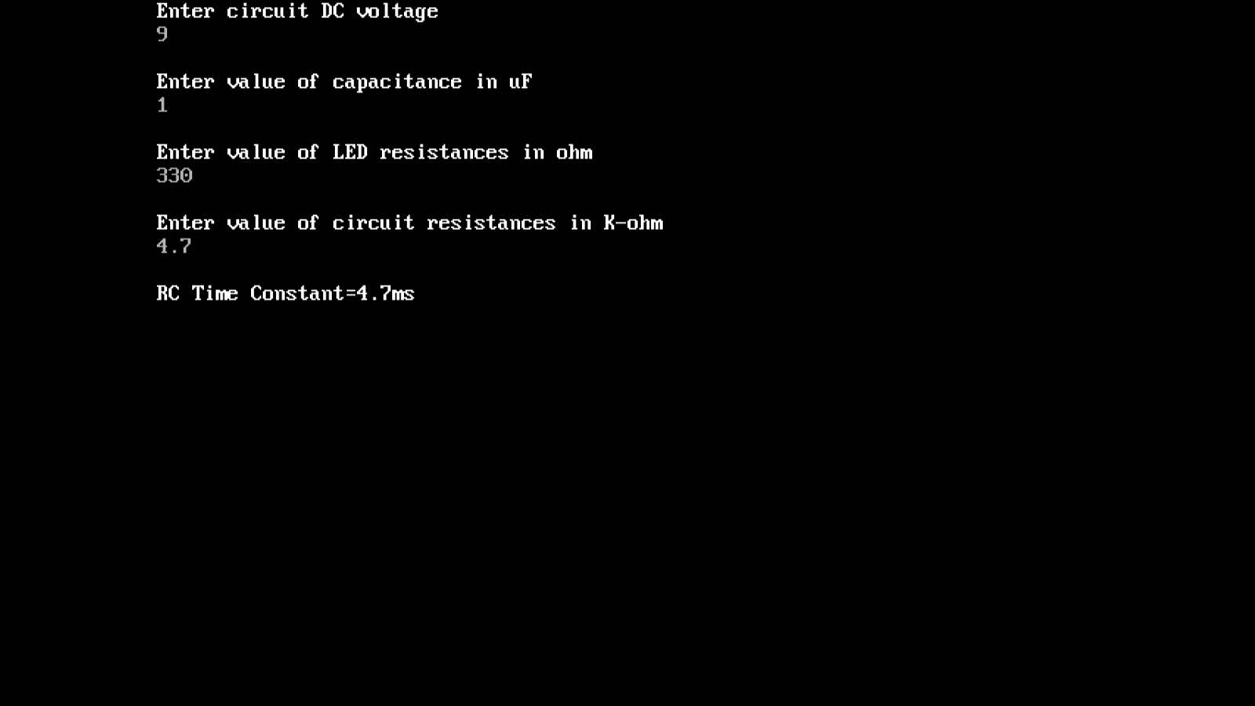

**INPUT PARAMETERS**

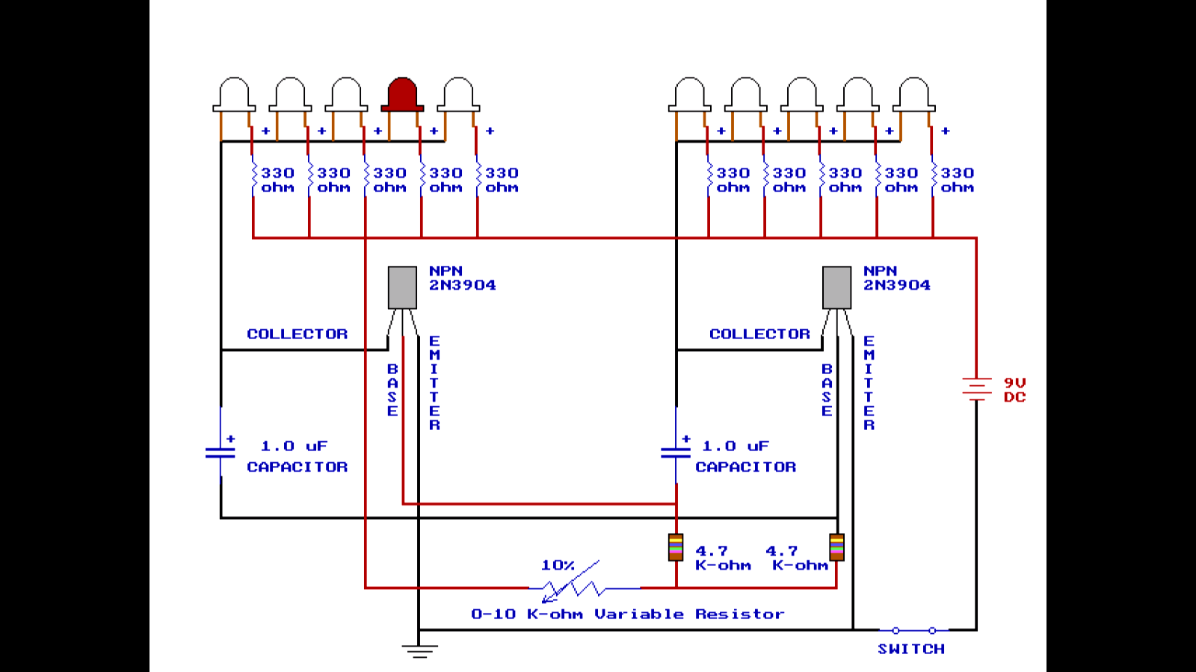

**RED LEDs GLOWS (STATE 1)**

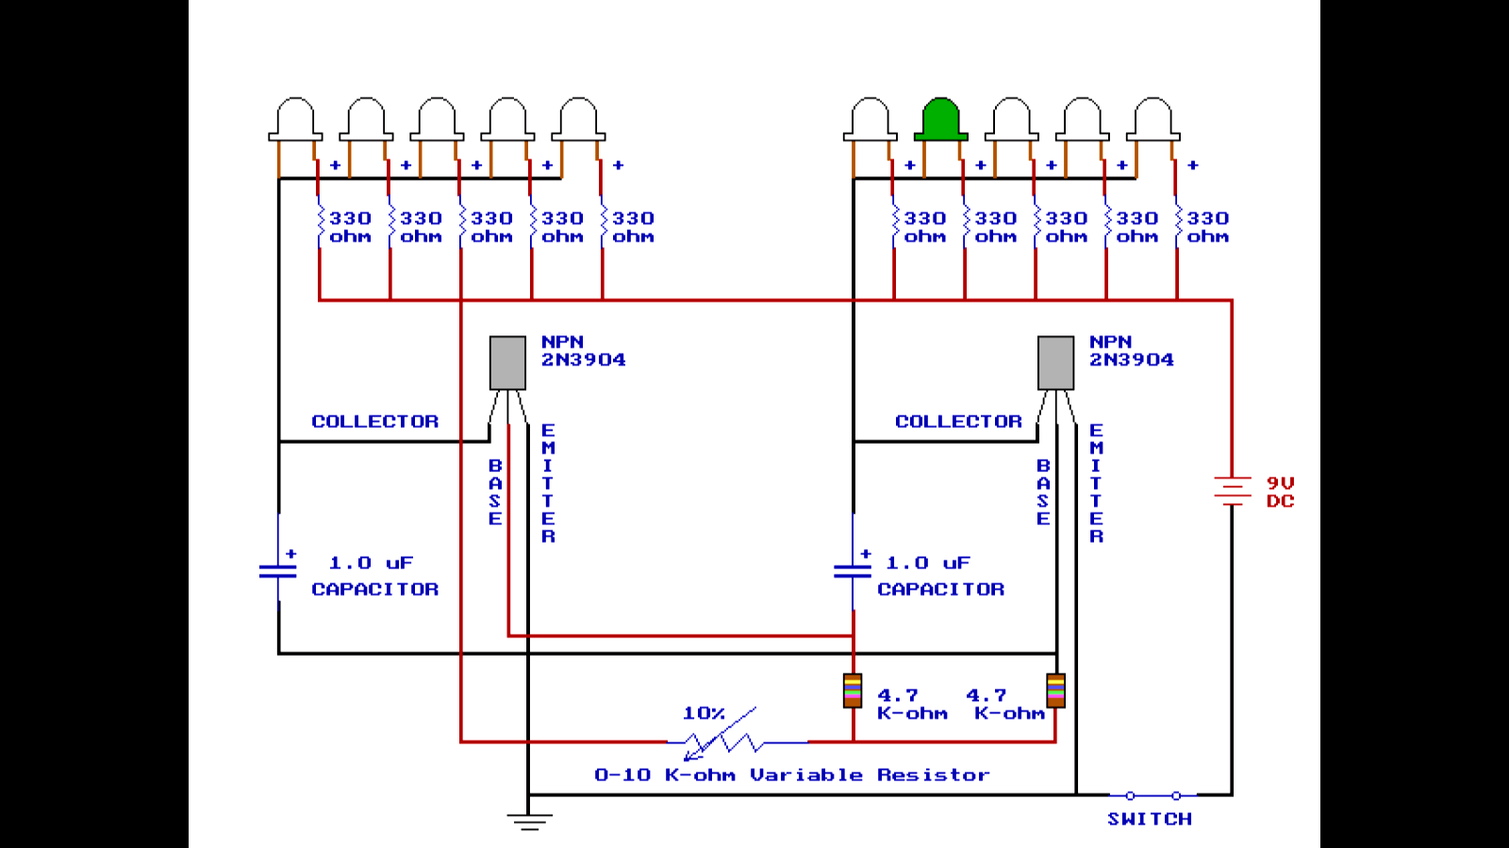

**GREEN LEDs GLOWS (STATE 1**